
ModernCop for SDL 6.1 Getting Started Guide
January 2014
SDL Policy & Tools
Contents
Document History 1
Overview 2
Current Usage Modes 2
Installation 2
For Previous Users of ModernCop 2
System Requirements 2
Download Link 3
Uninstall 3
Installing ModernCop 3
Walkthrough 4
Running ModernCop from the Command Prompt 4
Running ModernCop from Visual Studio 5
Support 6

Document History
Document Status: Approved & Final
Date | Reviewer or Author | Comments
8/5/2013 | IanMcM | SDL 6.1 Beta
1/2/2014 | v-joobr | RTM ready
5/2/2014 | IanMcM | Document bug fixes

Overview
ModernCop evaluates both client-based and web-based JavaScript applications and Windows Store app packages by utilizing a rule set that is applied to formatting, syntax, and semantic analysis. Note that this document does not cover disabling and enabling analysis from within a file, annotations for specifying data types and other information, Visual Studio XML document comments, or updating WINRT JavaScript from WINMD. For a more complete description of ModernCop capabilities see Modern Cop for SDL 6.1 User Guide, available at http://codebox/ModernCop.
By reading this document and performing the sample exercise you can expect to gain a general understanding of the following:
- What ModernCop does and the value it can add to your security strategy.
- The software requirements for ModernCop.
- The installation procedure.
- How to run analyses from Visual Studio and from the Command Prompt.
- The terminology used in ModernCop.

Current Usage Modes
ModernCop supports two usage modes:
- Use from within Visual Studio for analysis during the development process.
- Execution from the command-line for analysis in build systems, lab runs, etc.

Installation

For Previous Users of ModernCop
To avoid certain incompatibilities between releases of ModernCop, all previous versions of the tool must be uninstalled.

System Requirements
- Microsoft Visual C++ 2010 Redistributable Package or newer is required to run ModernCop.
- ModernCop does not have any compiler dependencies.

Operating System Support
The following table lists the operating systems supported by ModernCop for SDL 6.1.
Operating System | Supported
Windows Vista | No
Windows 7 | Yes
Windows 8 | Yes
Windows 8 ARM | No
Windows 8.1 | Yes
Windows 8.1 ARM | No
Windows Server 2008 | Yes
Windows Server 2008 R2 | Yes
Windows Server 2008 Server Core installation option | Yes
Windows Server 2008 R2 Server Core installation Option | Yes
Windows Server 2012 | Yes
Windows Server 2012 Server Core installation option | Yes
Table 1 Supported Operating Systems

Download Link
Click the Download button at http://codebox/ModernCop to open the folder that contains the self-extracting executable.

Uninstall
Delete the directory where ModernCop was installed.

Installing ModernCop
Click the Download button at http://codebox/ModernCop to open the folder that contains the self-extracting executable.
Double-click the ModernCop.exe file. When the 7-zip Self Extracting Archive dialog opens, select a directory to install to and click Extract. We recommend installing to a standalone directory to simplify the management of ModernCop binaries.

Other Installation Information
Previous versions of ModernCop can be found on http://codebox/ModernCop.

Integrating ModernCop with Visual Studio
ModernCop is designed to work well when integrated with Visual Studio as an external tool. To create an entry for ModernCop in the Tools menu of Visual Studio, take the following steps (Note: You must have a full version of Visual Studio installed, Team Explorer versions of the Visual Studio will not be able to run external tools):
- Install ModernCop as described in “Installing ModernCop”.
- Launch Visual Studio. From the Tools menu, select External Tools.
- Click the Add button.
- Enter a Title for the entry. The text you provide will appear in Visual Studio’s Tools menu.
- Enter the path to ModernCop in the Command field. The ModernCop executable name is mod50.exe.
- Specify /file:$(ItemPath) in the Arguments field. This will direct ModernCop to run against the currently active document only.
Note: This approach will not invoke the ModernCop package checks. In order to run the ModernCop package-level analysis, specify /appx:$(ProjectDir) in the Arguments field.
Note: To restrict ModernCop analysis to rules that are relevant to security and the SDL, specify /groups:sdl as an additional argument to the tool.
- Specify the directory that holds mod50.exe in the Initial directory field.
- Be sure to select the Use Output window check box.
- Click OK.
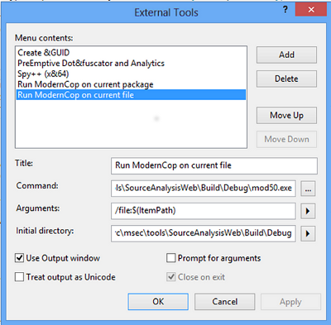
Figure 1 Adding ModernCop as an External Tool to Visual Studio

Walkthrough

Running ModernCop from the Command Prompt
The primary function of ModernCop is to analyze JavaScript and HTML files. (CSS file support will soon be available.) This is accomplished via the analyze command. This command is the ModernCop default and is optional on the command-line. To analyze a file, pass one or more /file or /dir arguments that resolve to references to files with .js, .html, or .htm extensions. Both /file and /dir arguments accept wildcards and environment variables. The /dir argument will recursively search child directories. Additionally, use the /groups switch with “SDL” as the argument to enable the SDL required checks.
The following are examples of valid commands. Note again that the presence of analyze is optional and it has been dropped in the final three examples.
Note: The colon separator is optional for most multi-part command-line arguments in ModernCop.
mod50.exe analyze /groups:SDL /file:MySite.js /file MySite.html
mod50.exe analyze /groups:SDL /file c:\sites\*.js
mod50.exe /groups:SDL /dir %MYSITES%\*.js /file:..\..\MySite.html
mod50.exe /groups:SDL /dir:c:\sites\*.html /dir:c:\sites\*.js
mod50.exe /groups:SDL /appx MyAppX.appx
Entering the /dir command from the command prompt automatically specifies directory recursion; the /file command does not automatically specify recursion. For example, the command dir:c:\mydir\*.js will analyze all JavaScript files in \mydir and the child directories of \mydir. The command /file:c\mydir\*.js will analyze only the JavaScript files that exist in \mydir.

Running ModernCop from Visual Studio
In this walkthrough we will describe the basics of performing ModernCop analysis using both Visual Studio and the command prompt. For complete information on running ModernCop in any of the two supported modes, see the ModernCop User Guide for SDL 6.1, available at http://codebox/ModernCop.
If you have integrated ModernCop into Visual Studio, you can now run ModernCop seamlessly from Visual Studio. (Note: You must have a full version of Visual Studio installed, Team Explorer versions of the Visual Studio will not be able to run external tools).
- Open the JavaScript or HTML file to be analyzed in the Visual Studio editor.
- From the Main menu, select Tools and then select the menu entry that you entered in “Integrating ModernCop with Visual Studio”.
- The output window will be activated and ModernCop results will appear there.
- Double-click individual errors to jump to the source code location.
- After fixing the identified issues, save the file and rerun ModernCop.

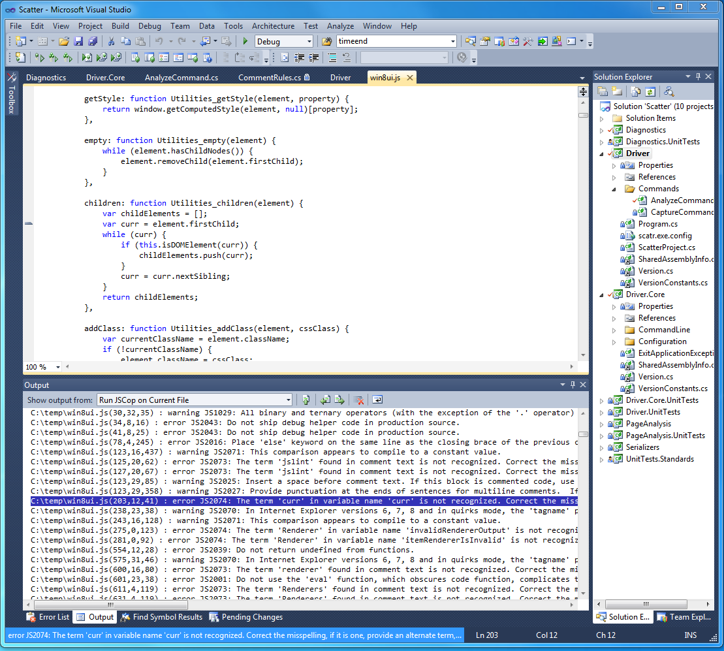
Figure 2 Highlighted Issue in Visual Studio Output Window

Support
For support, email ModernCop@microsoft.com
For additional information about ModernCop, or to report a bug, please visit http://codebox/ModernCop

Copyright © 2014 Microsoft Corporation. All rights reserved. This document is provided "as-is." Information and views expressed in this document, including URL and other Internet Web site references, may change without notice. You bear the risk of using it.
Some examples are for illustration only and are fictitious. No real association is intended or inferred.
This document does not provide you with any legal rights to any intellectual property in any Microsoft product. You may copy and use this document for your internal, reference purposes.

